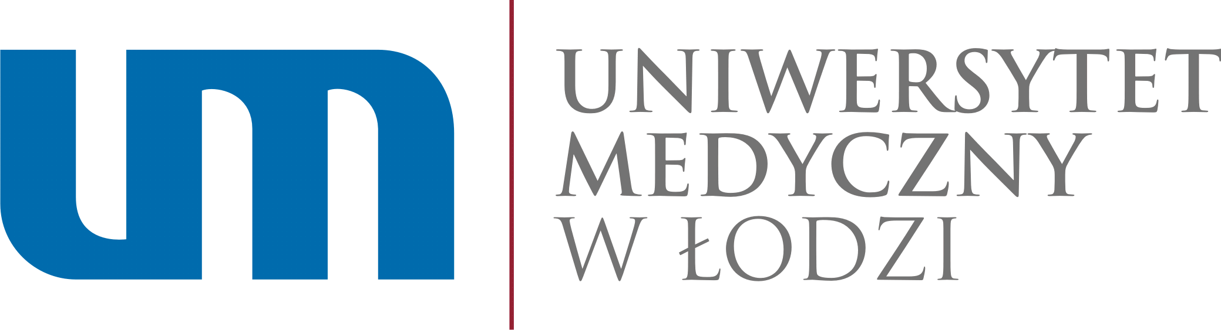

Łódź dn. ________________

CERTIFICATE

The International Relation Office of the Medical University of Lodz certifies that Mr./Mrs. …………………………………………………… student of the Medical University will undergo an internship abroad under the Erasmus+ program , in ………………………………………… Country ……………………., in the academic year 20..../20.... in the period from ... ............................ to ............. .........................

WYSTWAIŁ
Dział Współpracy Zagranicznej
Uniwersytetu Medycznego w Łodzi

